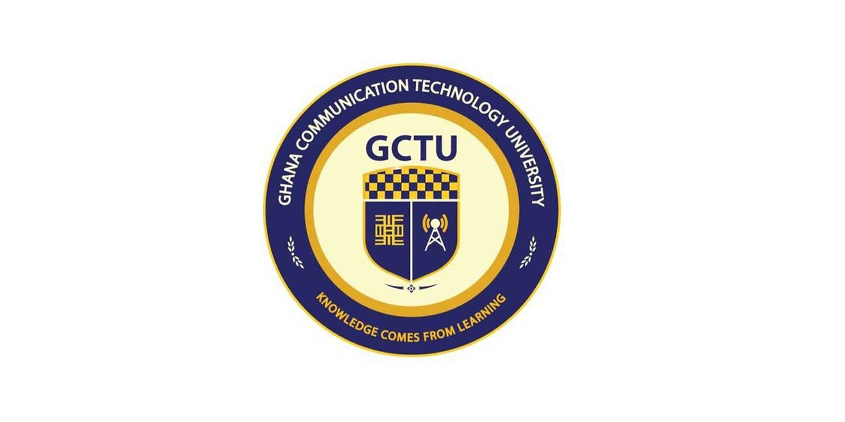**GHANA COMMUNICATION TECHNOLOGY UNIVERSITY**

**INTERNSHIP REPORT**

**By**

**KUSEAMO RICHARD JAMPANA**

**(4211219317)**

**Submitted to the**

**DEPARTMENT OF COMPUTER SCIENCE,**

**FACULTY OF COMPUTING AND INFORMATION SYSTEMS**

**Ho Campus**

**in Partial Fulfilment of the Requirements for the**

**AWARD OF BACHELOR OF SCIENCE INFORMATION TECHNOLOGY (BIT) DEGREE**

**INTERNSHIP REPORT**

**Acknowledgement**

I would like to express my deepest gratitude to the Ghana Revenue Authority Academy for providing me with the opportunity to undertake my internship as a student. I extend my sincere thanks to the ACADEMY SERGANT MAJOR ( **ASM )** RA II Frederick Mordzinu , The communication OFFICER ARO Emmanuel Agyei as my internship supervisors, for their guidance, support, and invaluable insights throughout my time at the academy. I am also grateful to all the staff members who welcomed me warmly and contributed to making my internship experience enriching and fulfilling. Additionally, I would like to thank my fellow interns for their camaraderie and collaboration. This internship has been a remarkable learning journey, and I am truly thankful for the support and encouragement I received from everyone at the Ghana Revenue Authority Academy.

**Abstract**

This internship report documents my experience and learning during a two-month internship at the Ghana Revenue Authority Academy as an IT student. The report provides insights into the projects I worked on, the skills I developed, and the challenges I encountered during my time at the academy. Key areas of focus include; the servicing of Desktop computers of the Academy, Development of an Asset Manager software for the Academy and the Development of A logistics Management system for the Academy. Through hands-on experience and mentorship from experienced professionals, I gained practical knowledge in the Installation of the Cooperate Wi-Fi network system for the **entire GRA nationwide**. Overall, the internship proved to be a valuable opportunity for professional growth and development, and I am grateful for the learning experiences it offered.

**Introduction**

The purpose of this internship report is to provide an overview of my two-month internship experience at the Ghana Revenue Authority (GRA) Academy, located in Kpetoe, Volta Region, Ghana. As an IT student, my internship was primarily aimed at gaining practical insights and hands-on experience in the field of information technology within the context of revenue administration.

The GRA is guided by a clear vision and mission that reflect its commitment to excellence and national development. The vision of the GRA is to become a world-class revenue administration recognized for its professionalism, integrity, and excellence. In line with this vision, the mission of the GRA is to mobilize revenue for national development in a transparent, fair, effective, and efficient manner.

My internship took place at the GRA Academy, where the training of officials is conducted to equip them with the necessary skills and knowledge to fulfill the organization's mission. Located in Kpetoe, Volta Region, Ghana, the GRA Academy serves as a hub for professional development and capacity building, playing a crucial role in supporting the GRA's overarching goals of revenue mobilization and national development. Throughout my internship, I had the opportunity to contribute to these objectives while furthering my own understanding of IT systems and their application in revenue administration.

**Significance of the internship to the student**

The relevance of the internship at the Ghana Revenue Authority Academy to my academic and professional journey cannot be overstated. This period of practical training served as a bridge between the theoretical knowledge acquired in the classroom and the real-world application of information technology within the professional sphere, particularly in the field of revenue administration. The experience has been instrumental in shaping my understanding of the IT landscape, enhancing my technical skills, and preparing me for future career opportunities. Below are various aspects that underscore the importance of this internship to my personal and professional development.

* **Practical Exposure to IT Systems**

One of the most significant benefits of this internship was the opportunity to gain hands-on experience with advanced IT systems and technologies used in revenue administration. Working on projects such as the development of Asset Manager software, servicing desktop computers, and participating in the installation of a corporate Wi-Fi network provided me with a practical understanding of how technology underpins the operations of a major revenue authority. This exposure was invaluable in helping me connect the dots between theoretical concepts learned during my academic studies and their practical applications in a professional setting.

* **Skill Development**

The internship facilitated a substantial growth in my technical and soft skills. On the technical front, I became proficient in various software development tools, network installation techniques, and IT service management practices. These skills are crucial for my future career in IT and have given me a competitive edge as I enter the job market. Equally important were the soft skills I developed, including problem-solving, effective communication, and teamwork. Working alongside experienced professionals and fellow interns, I learned how to articulate technical information clearly, collaborate on complex projects, and navigate the challenges that arise in a dynamic work environment.

* **Professional Networking**

The internship at the Ghana Revenue Authority Academy provided a platform to build professional relationships and network with individuals in my field of interest. Interacting with IT professionals, academy staff, and fellow interns allowed me to learn from their experiences, seek advice, and understand the dynamics of working within a government institution. These connections are invaluable resources that could open doors to future job opportunities, mentorship, and professional collaborations.

* **Real-World Problem Solving**

The practical experience of addressing real-world problems was another significant aspect of the internship. Whether it was diagnosing and fixing hardware issues, developing software to streamline asset management, or contributing to the implementation of a nationwide Wi-Fi network, each project presented its unique set of challenges. Tackling these issues head-on required a blend of creativity, critical thinking, and technical knowledge. This aspect of the internship was particularly rewarding as it not only tested my abilities but also instilled a sense of accomplishment and confidence in my problem-solving skills.

* **Insight into the Professional Environment**

The internship also offered a glimpse into the professional work environment, including the culture, ethics, and expectations of a government institution focused on revenue administration. Understanding the importance of professionalism, integrity, and accountability in such a context has been crucial. It has instilled in me the values and attitudes necessary to thrive in the professional world and contribute positively to any organization I may join in the future.

**Lessons learnt by the student**

Throughout the internship, I learned valuable lessons that extended beyond technical skills. I gained insights into effective communication and collaboration within a professional setting. Additionally, I learned the importance of adaptability and problem-solving in addressing various challenges encountered during project execution. These lessons have not only enriched my academic experience but have also equipped me with essential life skills necessary for success in any endeavor.

**Contribution of the student to the organization’s goals**

During my internship, I actively contributed to the organization's goals by undertaking several projects aimed at enhancing operational efficiency within the academy. This include;

1. **Servicing Desktop Computers:** During the internship, one of the key responsibilities was the maintenance and servicing of desktop computers used within the Ghana Revenue Authority Academy. This involved diagnosing hardware and software issues, performing repairs and upgrades, and ensuring that all systems were operating at optimal levels. By ensuring the reliability and functionality of these computers, I directly contributed to the smooth functioning of day-to-day operations at the academy. This, in turn, facilitated the training activities conducted at the academy, enabling staff members to effectively acquire and apply the necessary skills and knowledge for revenue administration.
2. **Development of Asset Manager Software:** Another significant project I undertook was the development of an Asset Manager software tailored to the specific needs of the Ghana Revenue Authority Academy. This software aimed to streamline the tracking and management of assets, including equipment, furniture, and other resources utilized within the academy. By creating a centralized system for asset management, I contributed to improving organizational efficiency and accountability. The software enabled staff members to easily access information about available resources, their locations, and their status, thereby optimizing resource utilization and minimizing instances of loss or misplacement. This initiative aligned with the organization's mission of transparency and effective resource utilization, ultimately supporting its broader goals of revenue mobilization for national development.
3. **Creation of Logistics Management System:** Additionally, I was involved in the development of a Logistics Management system designed to facilitate the planning, monitoring, and coordination of logistical activities within the Ghana Revenue Authority Academy. This system aimed to streamline processes such as inventory management, procurement, and distribution of materials and resources needed for training programs and other operational activities. By implementing this system, I contributed to enhancing the academy's logistical efficiency, reducing lead times, and minimizing costs associated with resource procurement and transportation. The Logistics Management system empowered staff members to efficiently manage logistical operations, ensuring that training programs and other activities were conducted seamlessly and without disruptions. This initiative directly supported the organization's mission of mobilizing revenue for national development by optimizing operational processes and maximizing the impact of its training programs.
4. **Involvement in Corporate Wi-Fi Network Installation:** One of the most significant contributions I made during my internship was my involvement in the installation of the corporate Wi-Fi network system for the entire Ghana Revenue Authority nationwide. This project aimed to enhance connectivity and communication within the organization, facilitating collaboration and information sharing among staff members across different locations. By participating in this initiative, I played a crucial role in improving the organization's technological infrastructure, enabling it to leverage modern communication technologies for enhanced productivity and efficiency. The corporate WiFi network system not only facilitated internal communication but also supported the implementation of online platforms and digital solutions for revenue administration, aligning with the organization's mission of leveraging technology for effective revenue mobilization.

**Challenges faced by the student**

Despite the enriching experience, I encountered various challenges during my internship. These included technical hurdles in software development, time constraints in meeting project deadlines, and adapting to the dynamic work environment of a government institution. However, these challenges provided valuable learning opportunities, allowing me to develop resilience and problem-solving skills essential for professional growth.

**Challenges faced by the organization**

The Ghana Revenue Authority Academy, like any organization, faced its share of challenges. These include resource constraints, technological limitations, and the need to continually adapt to evolving regulatory frameworks and technological advancements. However, through strategic planning, collaboration, and the dedication of its staff and interns, the organization strives to overcome these challenges and achieve its mission of transparent and effective revenue mobilization for national development.

**Recommendations**

1. **Continued Investment in Technology Infrastructure:** The Ghana Revenue Authority Academy should continue investing in upgrading its technology infrastructure to keep pace with evolving industry standards and technological advancements. This includes regular maintenance of IT systems, updating software applications, and providing adequate training to staff members to ensure optimal utilization of technology resources. By prioritizing technology investments, the academy can enhance operational efficiency and effectiveness in delivering training programs and other activities, ultimately contributing to the achievement of its goals.
2. **Enhanced Collaboration and Knowledge Sharing:** To foster a culture of collaboration and knowledge sharing, the Ghana Revenue Authority Academy should encourage regular interactions among staff members, interns, and other stakeholders. This can be achieved through organizing workshops, seminars, and networking events where participants can exchange ideas, share best practices, and learn from each other's experiences. By promoting collaboration and knowledge sharing, the academy can harness the collective expertise of its workforce to address challenges, innovate, and drive continuous improvement in its operations.
3. **Expansion of Training Programs:** In line with its mission of capacity building and professional development, the Ghana Revenue Authority Academy should consider expanding its training programs to cover a wider range of topics relevant to revenue administration. This may include specialized courses on emerging technologies, tax policies, and regulatory frameworks to equip officials with the knowledge and skills needed to navigate complex challenges in revenue mobilization. By diversifying its training offerings, the academy can cater to the evolving needs of its stakeholders and contribute to building a highly skilled workforce capable of driving sustainable economic growth and development.

**Conclusion**

My internship experience at the Ghana Revenue Authority Academy has been incredibly rewarding and enriching. Through hands-on projects and mentorship from experienced professionals, I have gained valuable insights into the field of information technology within the context of revenue administration. The academy's commitment to excellence and national development, as reflected in its vision and mission, has provided a conducive environment for learning and professional growth.

Despite encountering challenges along the way, such as technical hurdles and time constraints, I have emerged from this experience with a deeper understanding of IT systems, enhanced problem-solving skills, and a heightened sense of resilience. Moreover, my contributions to various projects aimed at improving operational efficiency within the academy have further reinforced my belief in the importance of leveraging technology for organizational success.

Looking ahead, I believe there are opportunities for the Ghana Revenue Authority Academy to further enhance its impact and effectiveness. By continuing to invest in technology infrastructure, promoting collaboration and knowledge sharing, and expanding its training programs, the academy can position itself as a leading hub for professional development in revenue administration. I am grateful for the support and encouragement I received from everyone at the academy and look forward to applying the lessons learned from this internship in my future endeavors.